**USER, HEALTHCHECK and EXPOSE instructions**

* Docker will use the root as the default user in the docker containers
* USER instruction can change this behavior and specify a non -root user ad default user

USER <user>

USER <user>:group

* Lets create a Dockerfile based on Apache Server for the Dockerfile

FROM ubuntu:18.04 LABEL author="khaja ibrahim" LABEL organization="QualityThought" RUN apt update && apt-get install apache2 -y USER www-data CMD ["whoami"]

* Now build the docker image

docker image build -t userdemo:1.0 .

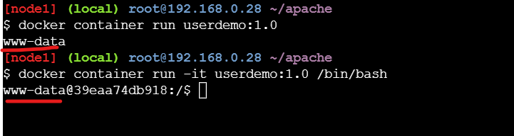

Create a container and keep it running in the background 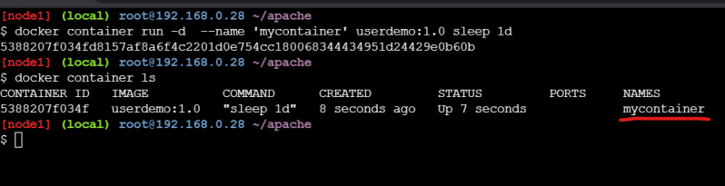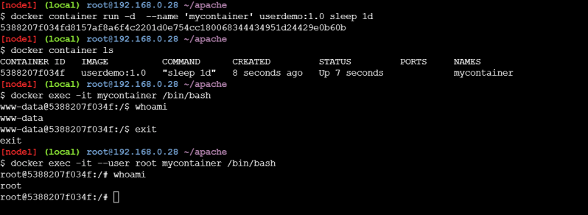

EXPOSE instruction is used to inform Docker that a container is listening on the specified port at run time

EXPOSE <port>

EXPOSE <port>/<protocol>

Ports exposed Expose instruction will only be accesible within docker container

To access the ports from the host we can use -p <host-port>:<container-port> or -P 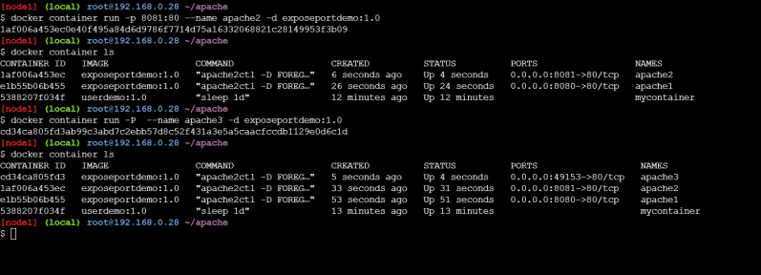

HEALTHCHECK: To verify if the application is running or not we can create HEALTHCHECK instruction

HEALTHCHECK --internal=1m --timeout=2s --retries=3 CMD curl -f http://localhost/ || exit 1

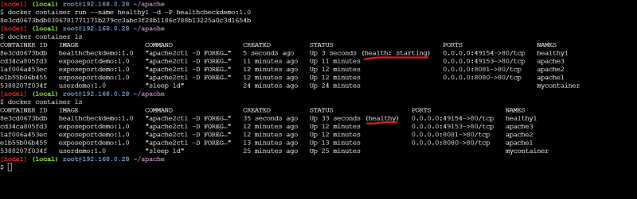

Let’s remove all the containers 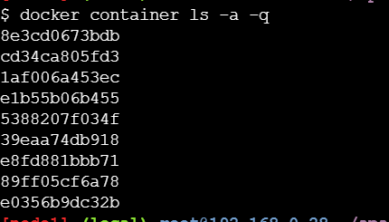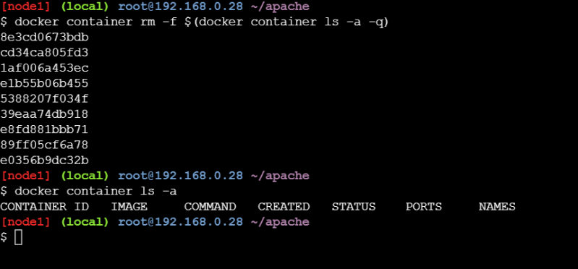

Let’s remove all the images 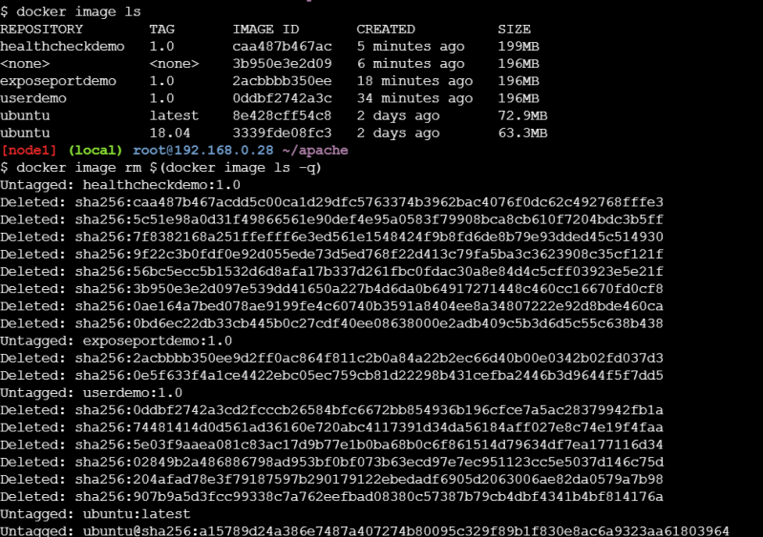

* All the containers are deleted as well as the images
* Lets understand how image layers impact docker container
* Changeset containing the Dockerfile
* FROM ubuntu:18.04
* LABEL author="khaja ibrahim"
* LABEL organization="QualityThought"
* RUN apt update && apt-get install apache2 -y && apt install curl -y
* HEALTHCHECK CMD curl -f http://localhost/ || exit 1
* EXPOSE 80
* CMD ["apache2ctl", "-D", "FOREGROUND"]

**Docker Storage**

Ideally, very little data is written to a container’s writable layer, and you use Docker volumes to write data. However, some workloads require you to be able to write to the container’s writable layer. This is where storage drivers come in.

Docker supports several different storage drivers, using a pluggable architecture. The storage driver controls how images and containers are stored and managed on your Docker host.

* The image layers are organized as shown below 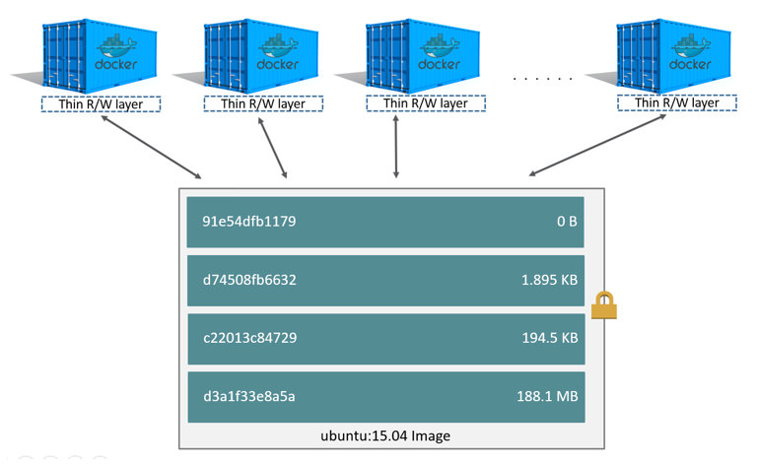
* Lets pull httpd and create 3 containers 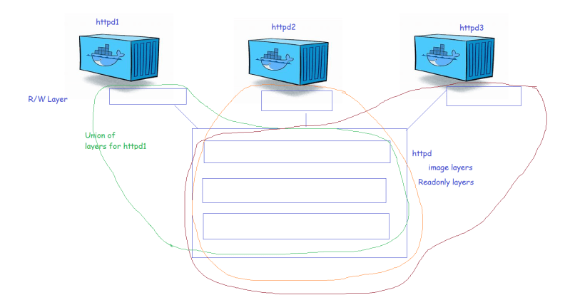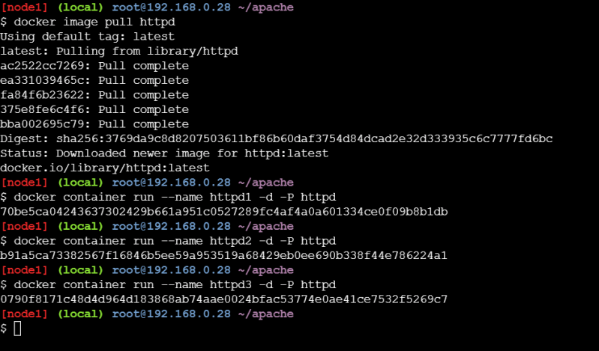
* Now lets run the docker container ls -s 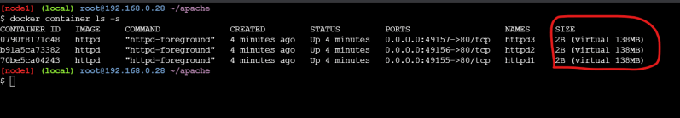
* SIZE is the actual size of the r/w layer and the virtual size the combined size of Image layer + R/W Layer 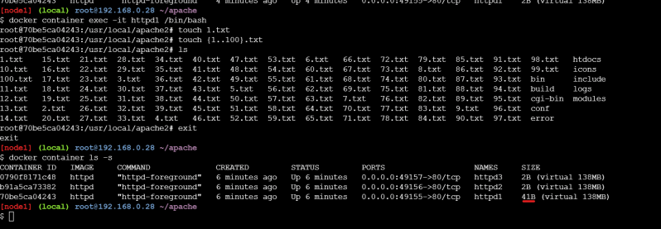
* Docker use Copy-on-write strategy (COW) to make changes in the existing files in the image layers
* To make this layers work docker uses storage drivers. Docker supports the following storage drivers
  + overlay2
  + aufs
  + devicemapper
  + brtfs storage driver
  + zfs storage drivers
* Official documentation. ( https://docs.docker.com/storage/storagedriver/select-storage-driver/)
* When the docker container is deleted the R/W layer is deleted and if the R/W layer is deleted we loose the data generated
* Before trying to resolve this let’s try to understand docker container states 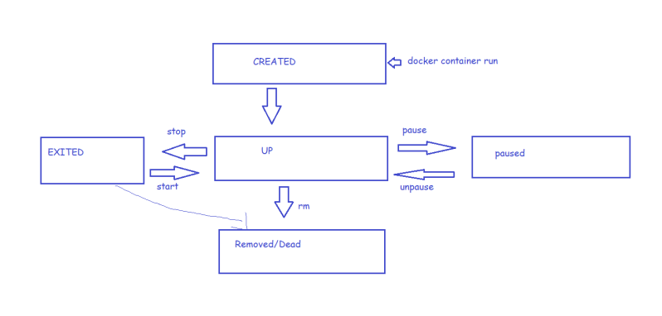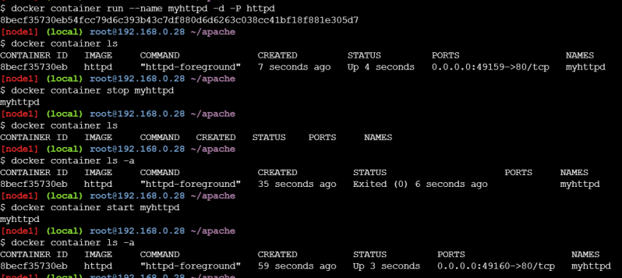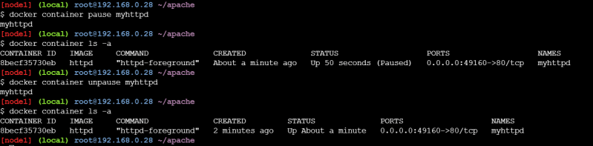

In all of the above states apart from Removed/Dead docker container data is still available on the docker host

But once we remove the container the data generated in the R/W layer will be deleted 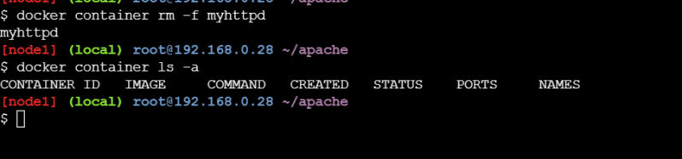

**Docker Volumes**

* We can use docker volumes to save the persisted data without relying on containers lifecycle
* If we create a docker volume and attach it to the container, even if the container is deleted the volume will still be available
* First option of creating a volume can be done in the Dockerfile, we can use the VOLUME instruction.
* LABEL organization="QualityThought"
* RUN apt update && apt-get install apache2 -y && apt install curl -y
* HEALTHCHECK CMD curl -f http://localhost/ || exit 1
* VOLUME ["/var/www/html"]
* EXPOSE 80
* CMD ["apache2ctl", "-D", "FOREGROUND"]

Now let’s build the image

docker image build -t voldemo:1.0 .

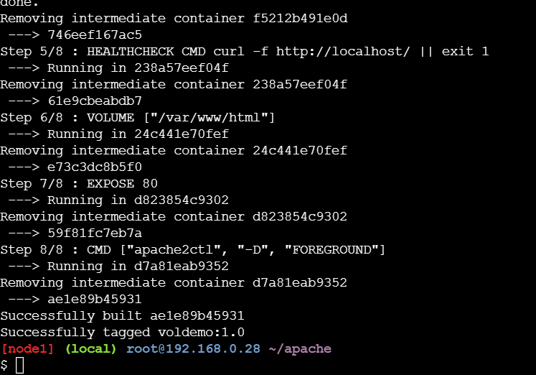

Let’s execute the following command

docker volume ls

Now lets create a container from this image 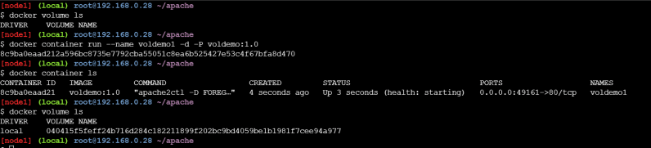

* Now lets create some dummy files in the /var/www/html folder 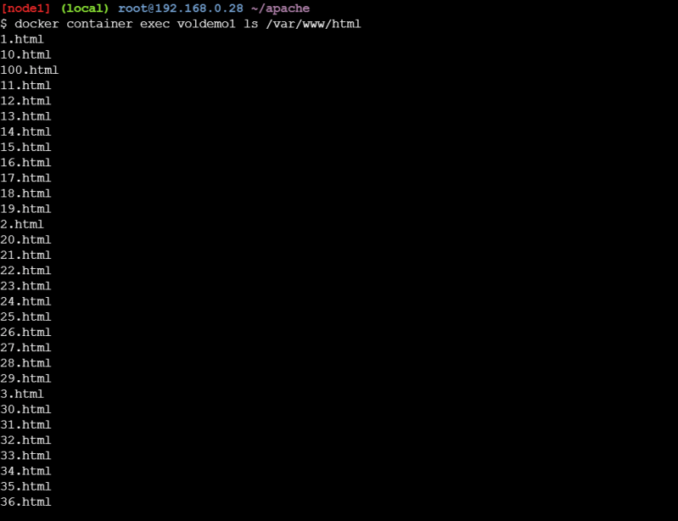
* Now lets inspect volume 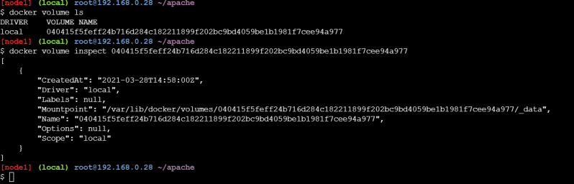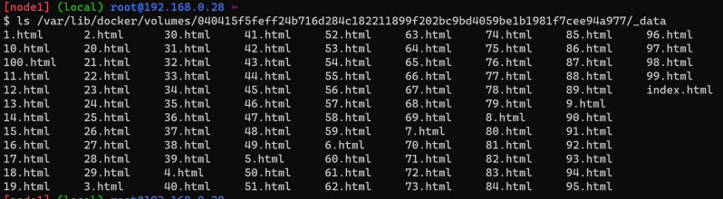
* Now let’s remove the container 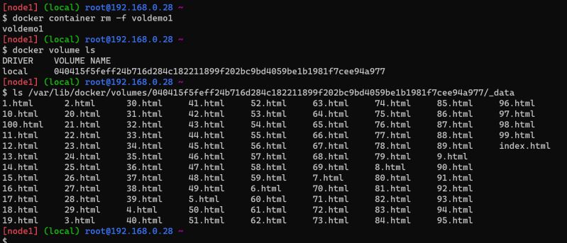
* Now even after we remove the container the volume is still present on the docker host and the data in the /var/www/html folder is retained.
* But this might not be the case as the Dockerfile will not contain volume instruction in all of the cases, so we need to understand how to use Docker volumes by attaching volumes to the containers
* To attach the volumes to the docker container we need to understand what different mount types are supported by the docker volumes
  + bind mount
  + volume mount
  + tmpfs mount 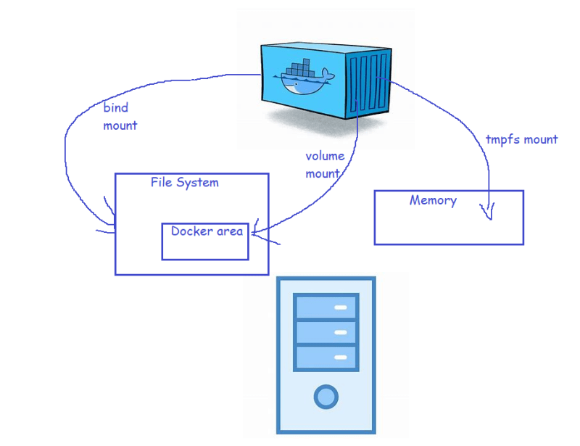
* In docker mounts can be done by two kinds of commands
  + -v
  + –mount
* Bind mount
* Lets create the container with bind mount

docker container run -d --name bindmountapache --mount "type=bind,source=/root/html,target=/var/www/html" -P httpd

docker container run -d --name bindmountapache2 -v "/root/html:/var/www/html" -P httpd

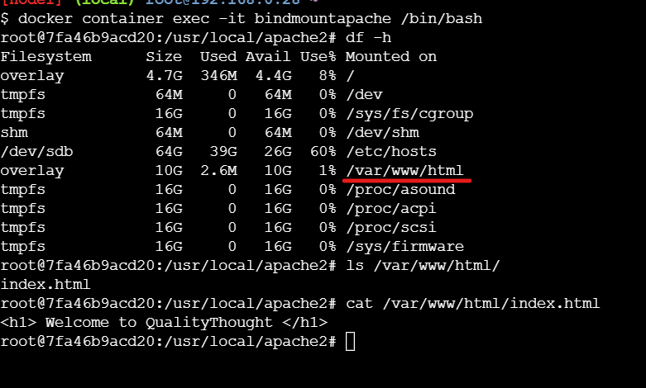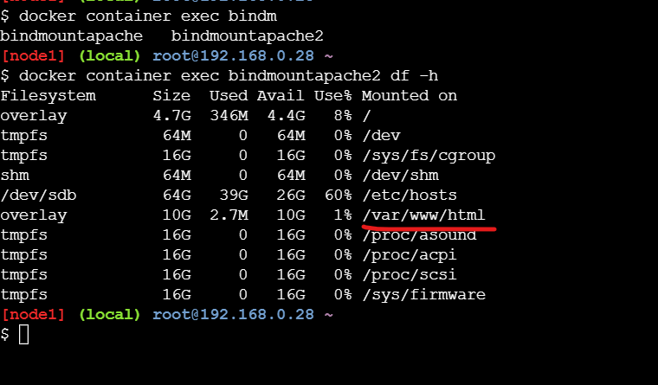

To make the mounts readonly

docker container run -d --name bindmountapache3 --mount "type=bind,source=/root/html,target=/var/www/html,readonly" -P httpd

docker container run -d --name bindmountapache4 -v "/root/html:/var/www/html:ro" -P httpd